Quick Start Guide

# Prerequisites:

Should be familar with:

1. Eclipse
2. Java
3. ImageJ
   1. https://imagej.net/Getting_Started

# Setup Development Environment:

1. Install java and the IDE
2. Visit <https://imagej.net/Developing_ImageJ_in_Eclipse> and follow the directions
3. Copy webhunter-plugin.zip to your compuer
4. Unzip the file
5. Start eclipse
6. Import the code
   1. Select File->Import

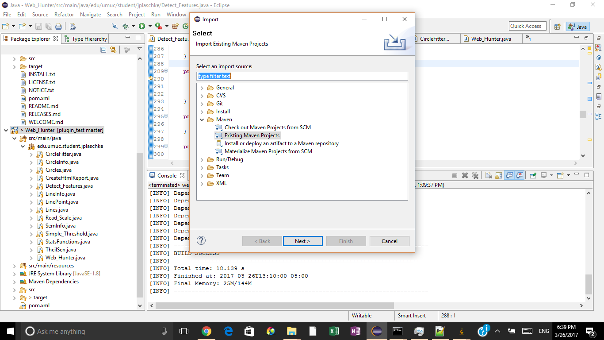

* 1. Choose Existing Maven Project
  2. Select the root directory for webhunter-plugin

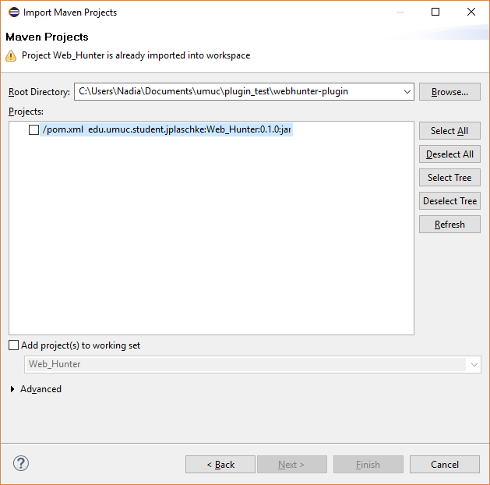

* 1. Check the pom.xml file and click Finish

1. To Run the program right click the project and select Run as -> Java Application

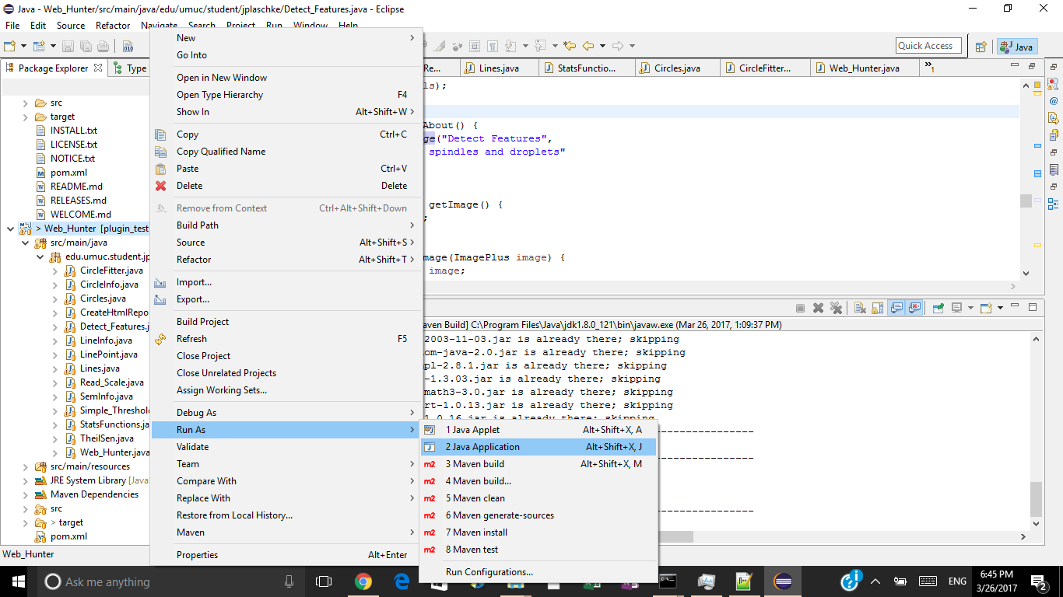

1. Select Web hunter



1. The program should start

# Code Overview

Web_Hunter.java implements the plugin and is the “main” class. Processing starts in the run() method

Web_Hunter uses other classes to do various functions

1. Read_Scale.java - finds the scale information
2. Get SEM annotation information. This uses OCR to read the magnification and scale
3. Simple_Threshold.java - simple thresholding. Change all pixel values greater than the threshold parameter to black. Change all pixel values less than the threshold parameter to gray,
4. Detect_Features.java - contains the code to detect lines and circles. Uses a simple state machine.
   1. Start at startingX x axis value
   2. Scan down vertical line to find the top edge of a spindle
   3. When top edge is found look for bottom edge
   4. If thickness is less than max spindle thickness then add point to line points
      1. If the line is the first point start a new line
      2. If the line is close to a line add to an old line
   5. Perform linear regression on groups of line points
   6. Use the lines that were found previously to look for circles
      1. “Walk” the parallel lines to detect left and right edges of circles
      2. Cluster the points that are within max distance
   7. Perform circle regression

NOTE: Lines.java, LinePoint.java, LineInfo.java, CircleInfo.java - data structures to hold information about the lines and circles